ShopNest Store Power BI Capstone

Step 1 - Merged product_category_name_translation table with Nexusgoods_products_dataset and rthen removed in final data

Below is the details of out and also attached the Power BI report which contains all the charts in different sheets.

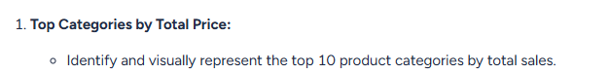
Answer – First Created the Total Price by adding Price and Freight Value, then calculated the Total Sale with Freight. In bar Product Category in Axis and Total sales with Freight in Values. In Filter Top N with show Items 10. Below is the output.

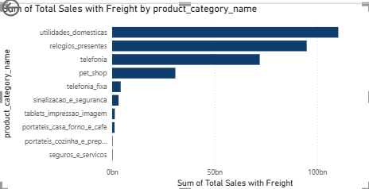

First calculated all the delayed and on time orders, then counted the delayed orders. In table take all the product category and delayed order counts

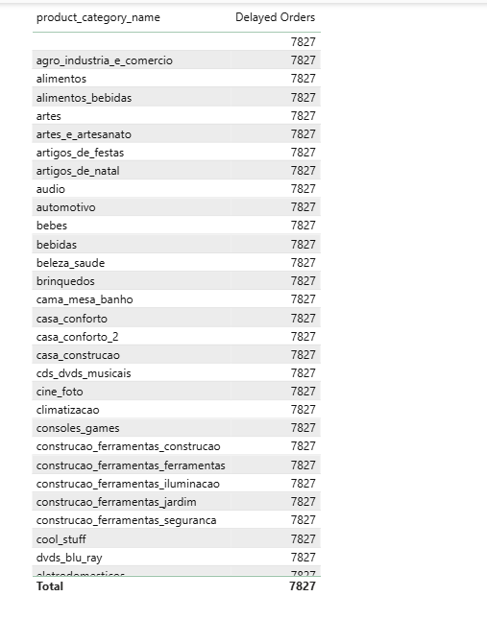

Created Table and Bar chart and below is the output
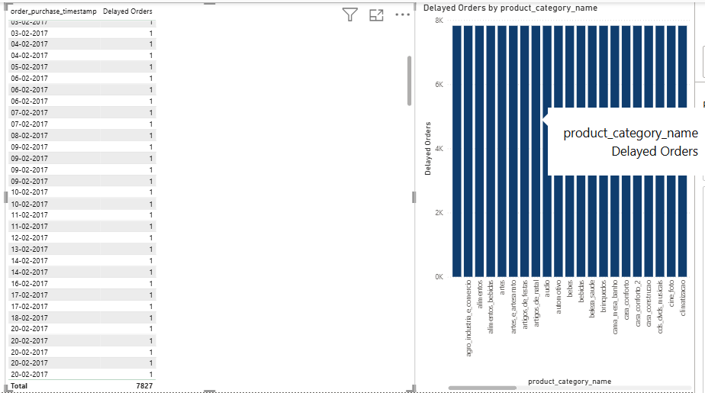

Below is the output in pie chart
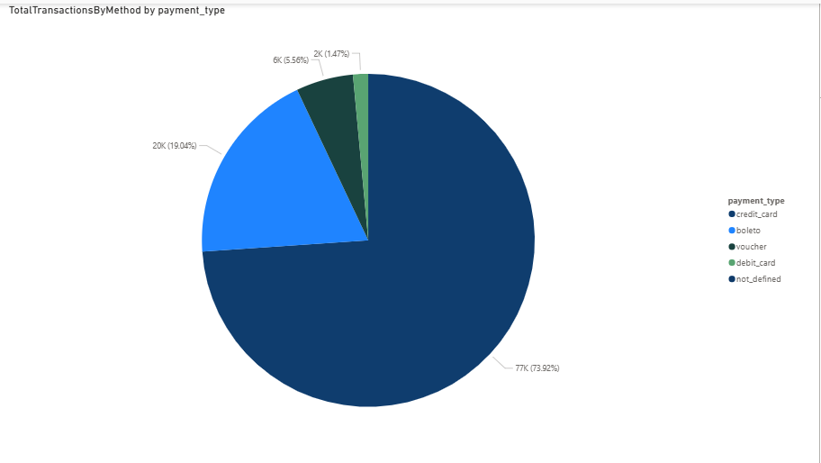

As per below chart we can identify top 10 and lowest rated product
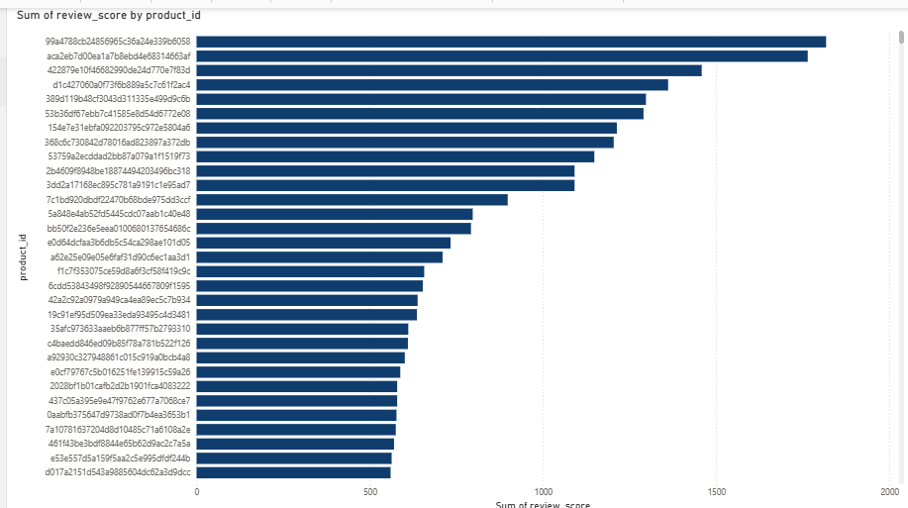

Below is the state wise analysis for high and low sales
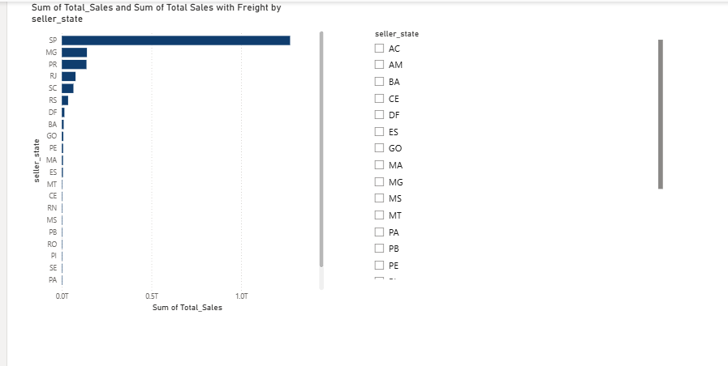

Below is quarterly pattern for sales over time
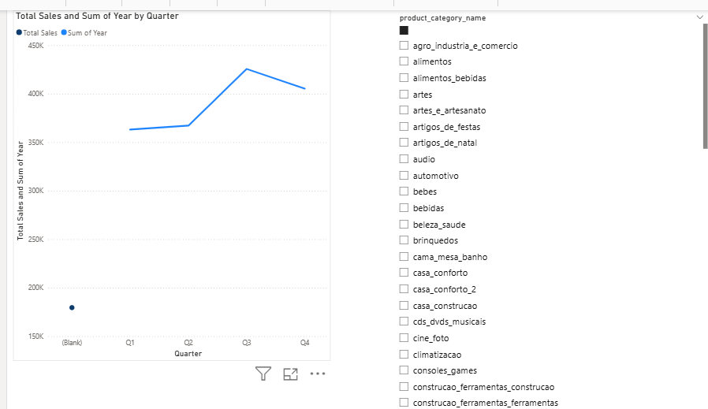

Please find the total revenue and changes details over an time period.
